ENG 260
Chapter 1 Quiz
ANSWERS

- The net charge through a cross section of a circuit element is given by:
q(t) = 2 + 3t C. Find the current through the element.

i(t) = dq(t)/dt = 3 coulombs/sec.t = 3 Amperes = 3A

2.) Calculate the power for each circuit shown. If each element is a battery, is it
being charges or discharged?
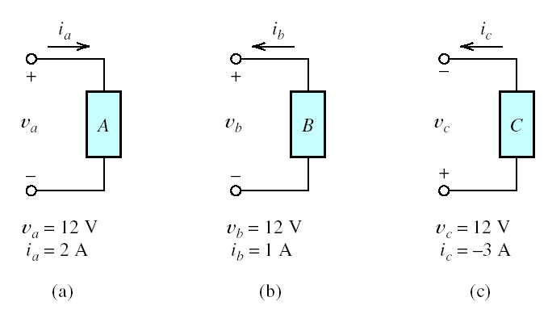

(a) p_{a} = v_{a}i_{a} = 12 V x 2 A = 24 W; energy is being absorbed by the element
(b) p_{b} = - v_{b}i_{b} = - 12 V x 1A = -12W; energy is being supplied by the element
(c) p_{c} = v_{c}i_{c} = 12V x (-3A) = -36W; energy is being supplied by the element

3.) Identify the elements that are in series and the circuits that are in parallel
in the circuit shown.

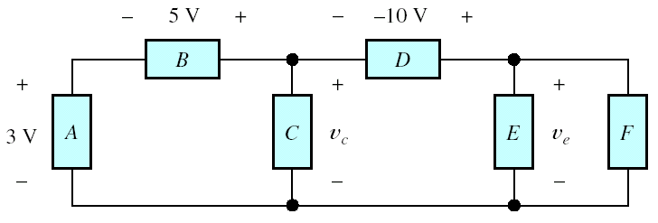

A and B are serial
and E and are parallel

4.) State Kirchhoff’s Current Law in your own words.

The net current entering a node is zero, or the net current leaving a node is zero.

5.) A certain wire has a resistance of 0.05 Ω. Find the new resistance a. if the
length of the wire is doubled, b. if the diameter of the wired is doubled.

R = (ρL)/A a. If the length is doubled, the resistance is doubled.
A = π (d/2)² b. If the diameter is doubled, the resistance is quartered.

6.) Use repeated application of KCL to find the values of v_{c} and v_{e} for the
following circuit.

- 3V -5V + v_{c} = 0
v_{c} = 8V

- v_{c} – (-10V) – v_{e} = 0
- 8V + 10V –v_{e} = 0
v_{e} = 2 V

